**Assignment-2**

JavaScript & Python Programming

|  |  |
| --- | --- |
| Student | S jothi prasad |
| Student Roll Number | 6113191031040 |
| Maximum Marks |  |

**Question-1:**

Execute the programs which are discussed on today session.

Solution:

<!doctype html>

<html>

<head>

<title>Javascript Program</title>

</head>

<body>

<h1>My JS first program</h1>

<p id = "demo">JS can change the style of an HTML element</p>

<script>

function myFunction()

{

document.getElementById("demo").style.fontsize = "50px";

document.getElementById("demo").style.color = "red";

document.getElementById("demo").style.backgroundColor = "yellow";

}

</script>

<button type = "button" onclick = "myFunction()"> clickhere </button>

</body>

</html>

Output:

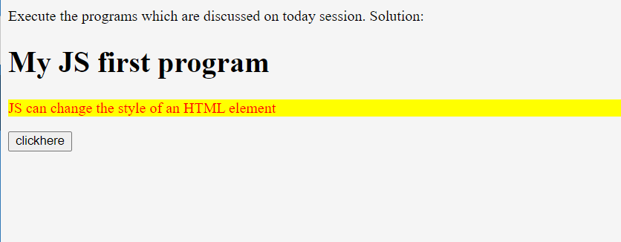

**Question-2:**

JavaScript Programs for Practice.

Solution:

Sample Program-1:

<!DOCTYPE html>

<html>

<body>

<h1>My First Web Page</h1>

<p>My First Paragraph</p>

<p id="demo"></p>

<script>

document.getElementById("demo").innerHTML = 5 + 6;

</script>

</body>

</html>

Output:

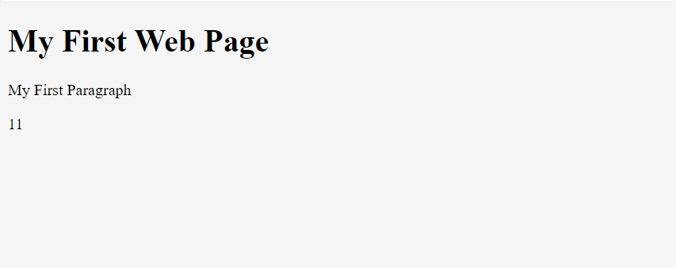

Sample Program-2:

<!DOCTYPE html>

<html>

<body>

<h1>My First Web Page</h1>

<p>My first paragraph.</p>

<script>

document.write(5 + 6);

</script>

</body>

</html>

Output:

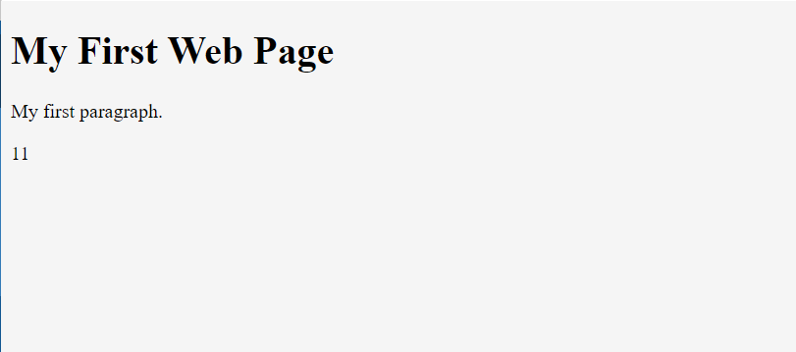

**Question-3:**

Python sample programs.

Solution:

Sample Program-1:

thislist = ["apple", "banana", "cherry"]

print(thislist)

Output

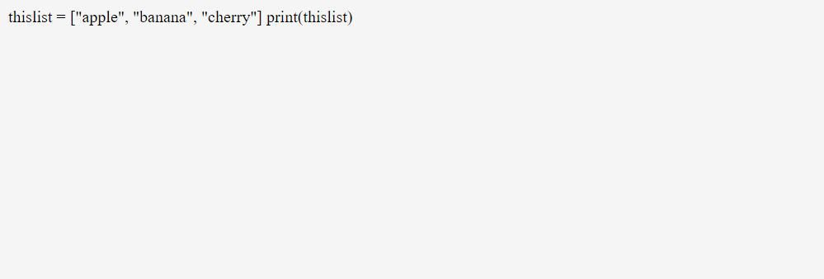

Sample Program-2:

thistuple = ("apple", "banana", "cherry")

print(thistuple)

Output:

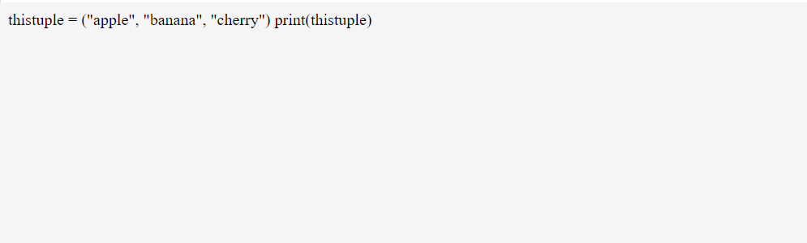

Sample Program-3:

thisset = {"apple", "banana", "cherry"}

print(thisset)

Output:

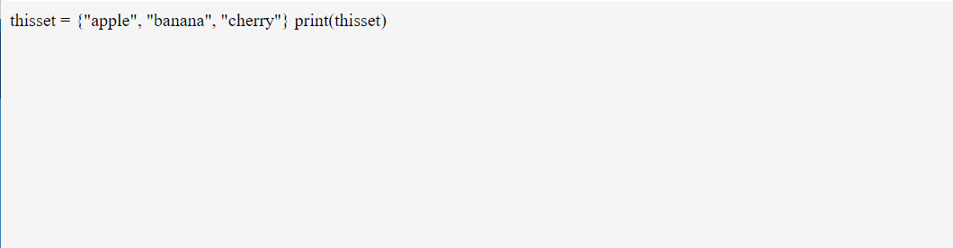

Sample Program-4:

thisdict ={ "brand": "Ford", "model": "Mustang","year": 1964}

print(thisdict)

Output:

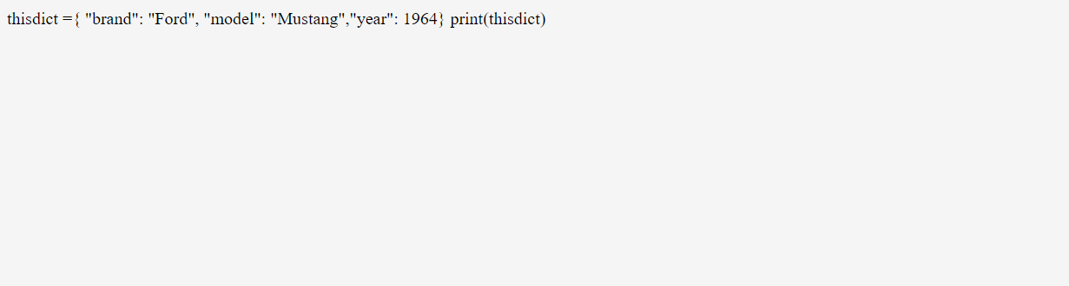

Sample Program-5:

a = 33

b = 200

if b > a:

print("b is greater than a")

Output:

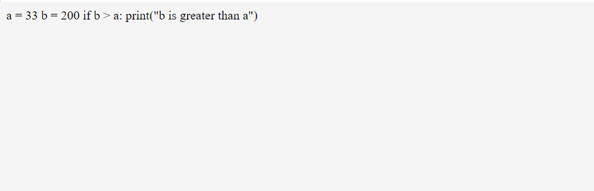

Sample Program-6:

fruits = ["apple", "banana", "cherry"]

for x in fruits:

print(x)

Output:

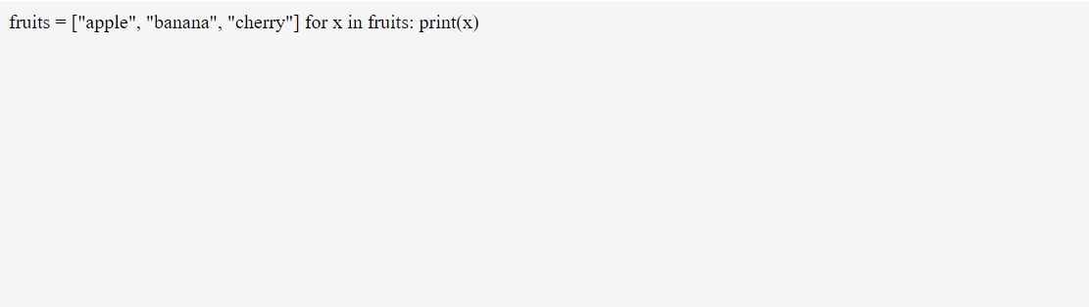

Sample Program-7:

def my_function():

print("Hello from a function")

my_function()

Output:

